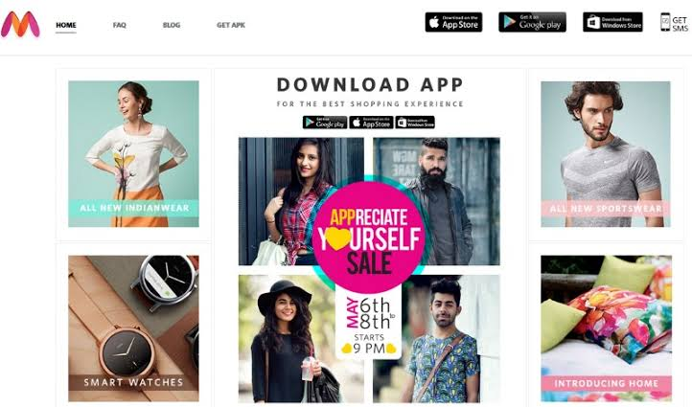

Project Name : MYNTRA

_

D. Sai charan

**Edureka Presents**

Overview

Myntra is a leading online store, offering a comprehensive range of fashion and lifestyle products. It allows shoppers to choose from a wide variety of national and international brands. Myntra sells everything from clothing to fashion accessories, footwear, watches, sunglasses, personal care and grooming items, sports and active wear, and bags and bagpacks. Myntra also sells home & living products such as bed linen, furnishing, home décor items, cookware, utensils, and lamps and lighting.

Goals

1. Homepage

2. Product categories page ( eg: men, women, beauty, kids )

3. Profile page ( login / logout )

4. Payment page

5. Wish list & bag page

**History**

**Myntra began its journey as a B2B player in 2007. During its initial years, the company focused primarily on selling on-demand personalized gift items. It became a hub for customers who wanted to get personalized items such as mugs, T-shirts, mouse pads, etc. From 2011, Myntra switched over to fashion and lifestyle products and discontinued its personalization business. In 2014, Myntra was acquired by Flipkart. The deal was valued at USD 280 million. However, Myntra continues to function as an independent company.**

**Technologies used in MYNTRA**

**Site Info – Myntra.com**

**Overview of web technologies used by Myntra.com.**

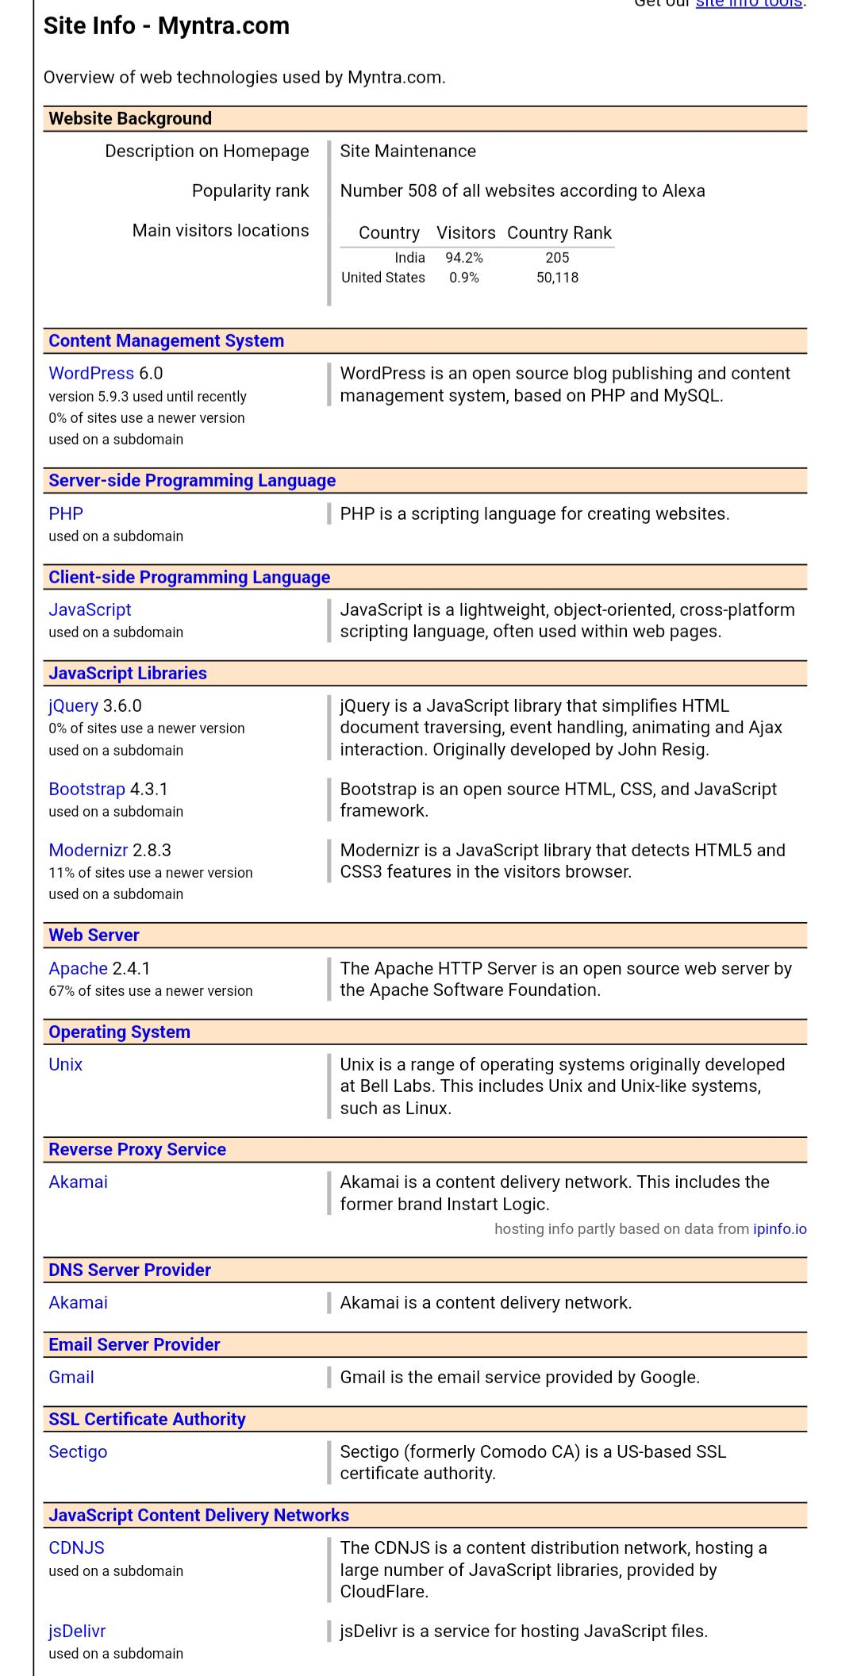

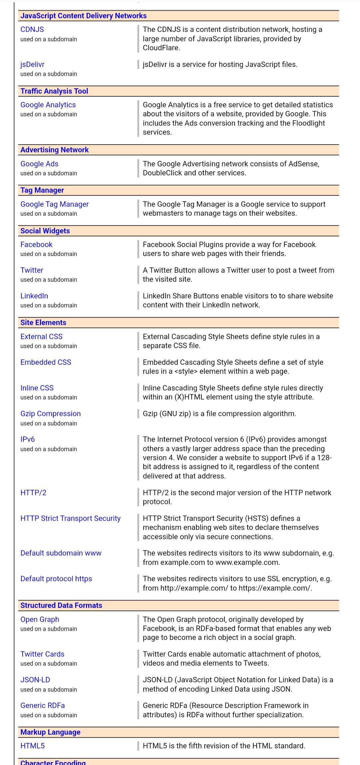

**Front end:**

**1.HTML**

**2. CSS**

**3. JAVASCRIPT**

**4. BOOTSTRAP**

**5. JQUERY**

**THANKS AND REGARDS**

**SAI CHARAN**

